


[Date]
PROJET WEB SEMANTIQUE FASODBPEDIA

OUEDRAOGO Issouf METOUALE SOMDA D. Augustin
Esi

Les répertoires

RDF : c’est le répertoire qui contient les jeux de données, chaque sous répertoire correspond à un jeu de donneés et le sous repertoires contients le fichier rdf serialisé en deux format RDF/XML et Turtle. Aussi le fichier csv ou xls correspond est dans le repertoire.

RDFS : c’est le repertoire contenant le fichier RDFS de chaque jeux de donnés. Chaque fichier defini les classes et les property qui sont utilisé dans le RDF.

REQUETE SPARQL : contient un fichier contenant l’ensemble des requetes sparQl

1. afficher la liste des jeux de donneés avec son thème et le producteur qui lui a fourni

prefix rdf: <http://www.w3.org/1999/02/22-rdf-syntax-ns#>
prefix dct: <http://purl.org/dc/terms/>
prefix ns: <http://www.semanticweb.org/master/esi/ontologies/2021/fasopedia#>
prefix dcat: <http://www.w3.org/ns/dcat#>
PREFIX owl: <http://www.w3.org/2002/07/owl#>
PREFIX rdfs: <http://www.w3.org/2000/01/rdf-schema#>
PREFIX xsd: <http://www.w3.org/2001/XMLSchema#>
PREFIX adms: <http://www.w3.org/ns/adms#>
PREFIX dc: <http://purl.org/dc/elements/1.1/>
PREFIX dcterms: <http://purl.org/dc/terms/>
PREFIX foaf: <http://xmlns.com/foaf/0.1/>
PREFIX time: <http://www.w3.org/2006/time#>
PREFIX vcard: <http://www.w3.org/2006/vcard/ns#>

SELECT ?title ?theme ?publisher
where {
?x rdf:type dcat:Dataset.
?x dcterms:title ?title.
?x dcterms:publisher ?publisher.
?x dcat:theme ?theme
}

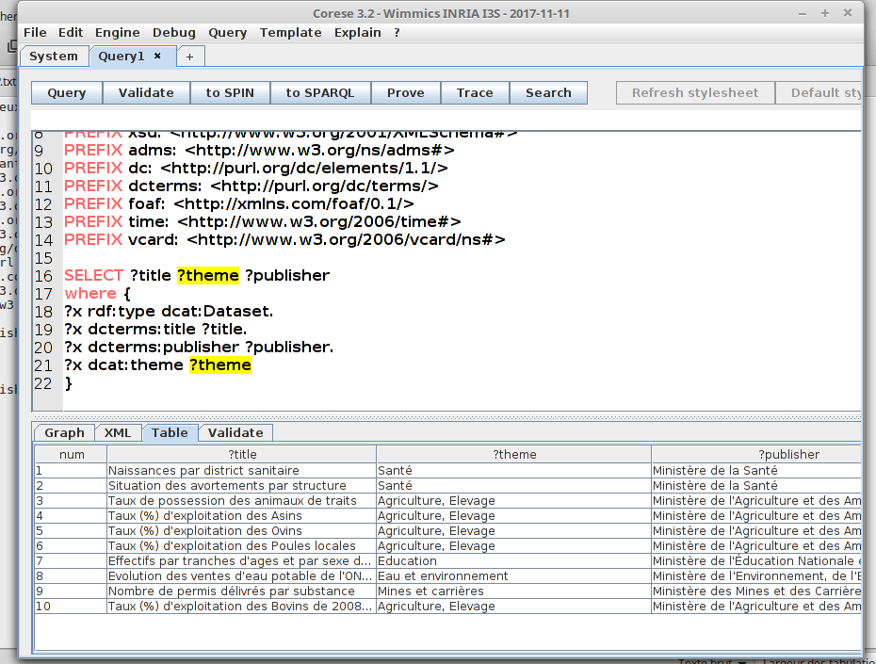

2. la liste des themes

prefix rdf: <http://www.w3.org/1999/02/22-rdf-syntax-ns#>
prefix dct: <http://purl.org/dc/terms/>
prefix ns: <http://www.semanticweb.org/master/esi/ontologies/2021/fasopedia#>
prefix dcat: <http://www.w3.org/ns/dcat#>
PREFIX owl: <http://www.w3.org/2002/07/owl#>
PREFIX rdfs: <http://www.w3.org/2000/01/rdf-schema#>
PREFIX xsd: <http://www.w3.org/2001/XMLSchema#>
PREFIX adms: <http://www.w3.org/ns/adms#>
PREFIX dc: <http://purl.org/dc/elements/1.1/>
PREFIX dcterms: <http://purl.org/dc/terms/>
PREFIX foaf: <http://xmlns.com/foaf/0.1/>
PREFIX time: <http://www.w3.org/2006/time#>
PREFIX vcard: <http://www.w3.org/2006/vcard/ns#>

SELECT ?theme
where {
?x rdf:type dcat:Dataset.
?x dcat:theme ?theme
}

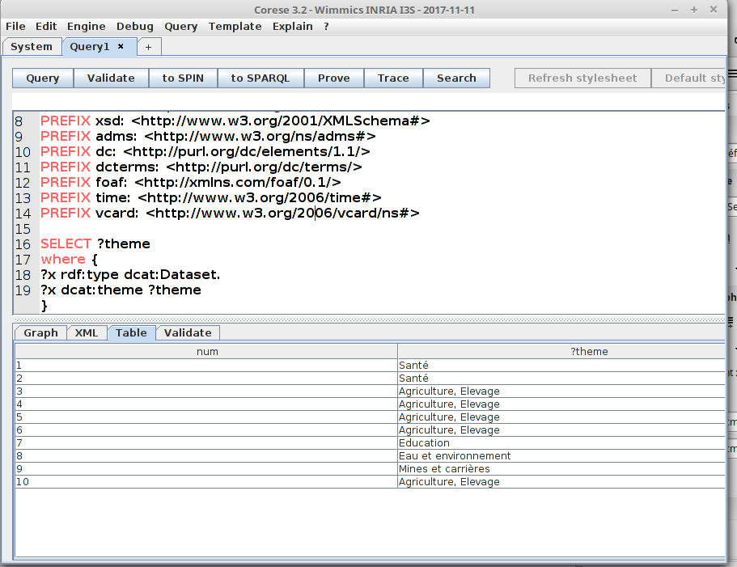
3. la liste des distribution sans de duplication
prefix rdf: <http://www.w3.org/1999/02/22-rdf-syntax-ns#>
prefix dct: <http://purl.org/dc/terms/>
prefix ns: <http://www.semanticweb.org/master/esi/ontologies/2021/fasopedia#>
prefix dcat: <http://www.w3.org/ns/dcat#>
PREFIX owl: <http://www.w3.org/2002/07/owl#>
PREFIX rdfs: <http://www.w3.org/2000/01/rdf-schema#>
PREFIX xsd: <http://www.w3.org/2001/XMLSchema#>
PREFIX adms: <http://www.w3.org/ns/adms#>
PREFIX dc: <http://purl.org/dc/elements/1.1/>
PREFIX dcterms: <http://purl.org/dc/terms/>
PREFIX foaf: <http://xmlns.com/foaf/0.1/>
PREFIX time: <http://www.w3.org/2006/time#>
PREFIX vcard: <http://www.w3.org/2006/vcard/ns#>

SELECT DISTINCT ?theme
where {
?x rdf:type dcat:Dataset.
?x dcat:theme ?theme
}

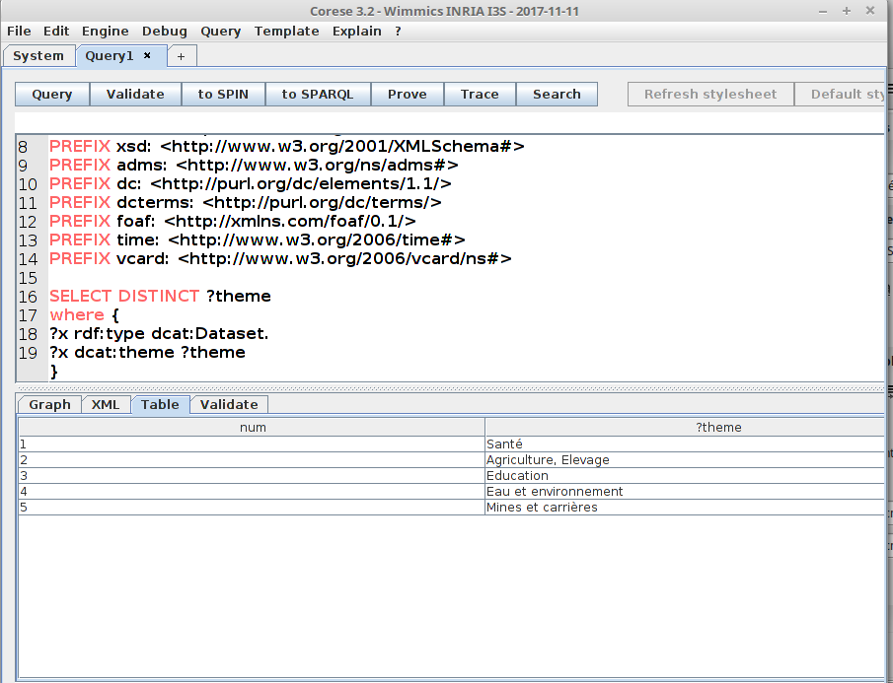

4. La liste des distributions

prefix rdf: <http://www.w3.org/1999/02/22-rdf-syntax-ns#>
prefix dct: <http://purl.org/dc/terms/>
prefix ns: <http://www.semanticweb.org/master/esi/ontologies/2021/fasopedia#>
prefix dcat: <http://www.w3.org/ns/dcat#>
PREFIX owl: <http://www.w3.org/2002/07/owl#>
PREFIX rdfs: <http://www.w3.org/2000/01/rdf-schema#>
PREFIX xsd: <http://www.w3.org/2001/XMLSchema#>
PREFIX adms: <http://www.w3.org/ns/adms#>
PREFIX dc: <http://purl.org/dc/elements/1.1/>
PREFIX dcterms: <http://purl.org/dc/terms/>
PREFIX foaf: <http://xmlns.com/foaf/0.1/>
PREFIX time: <http://www.w3.org/2006/time#>
PREFIX vcard: <http://www.w3.org/2006/vcard/ns#>

SELECT *
where {
?x rdf:type dcat:Distribution
}

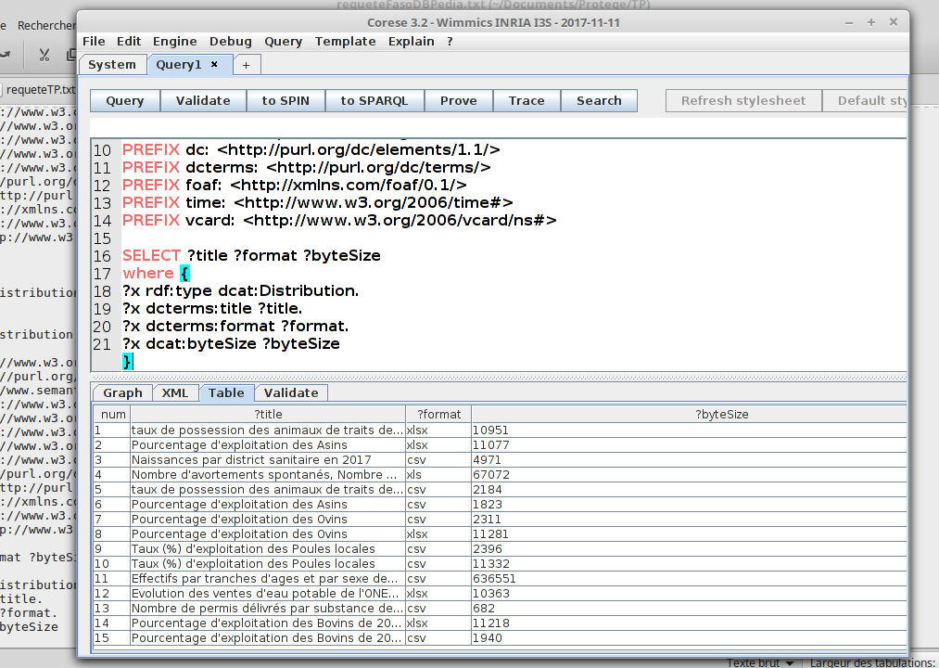

5. La liste des distribution en affichant le titre le format et la taille

prefix rdf: <http://www.w3.org/1999/02/22-rdf-syntax-ns#>
prefix dct: <http://purl.org/dc/terms/>
prefix ns: <http://www.semanticweb.org/master/esi/ontologies/2021/fasopedia#>
prefix dcat: <http://www.w3.org/ns/dcat#>
PREFIX owl: <http://www.w3.org/2002/07/owl#>
PREFIX rdfs: <http://www.w3.org/2000/01/rdf-schema#>
PREFIX xsd: <http://www.w3.org/2001/XMLSchema#>
PREFIX adms: <http://www.w3.org/ns/adms#>
PREFIX dc: <http://purl.org/dc/elements/1.1/>
PREFIX dcterms: <http://purl.org/dc/terms/>
PREFIX foaf: <http://xmlns.com/foaf/0.1/>
PREFIX time: <http://www.w3.org/2006/time#>
PREFIX vcard: <http://www.w3.org/2006/vcard/ns#>

SELECT ?title ?format ?byteSize
where {
?x rdf:type dcat:Distribution.
?x dcterms:title ?title.
?x dcterms:format ?format.
?x dcat:byteSize ?byteSize
}

6. affiche le titre et la taille des distribution au format CSV

prefix rdf: <http://www.w3.org/1999/02/22-rdf-syntax-ns#>
prefix dct: <http://purl.org/dc/terms/>
prefix ns: <http://www.semanticweb.org/master/esi/ontologies/2021/fasopedia#>
prefix dcat: <http://www.w3.org/ns/dcat#>
PREFIX owl: <http://www.w3.org/2002/07/owl#>
PREFIX rdfs: <http://www.w3.org/2000/01/rdf-schema#>
PREFIX xsd: <http://www.w3.org/2001/XMLSchema#>
PREFIX adms: <http://www.w3.org/ns/adms#>
PREFIX dc: <http://purl.org/dc/elements/1.1/>
PREFIX dcterms: <http://purl.org/dc/terms/>
PREFIX foaf: <http://xmlns.com/foaf/0.1/>
PREFIX time: <http://www.w3.org/2006/time#>
PREFIX vcard: <http://www.w3.org/2006/vcard/ns#>

SELECT ?title ?byteSize
where {
?x rdf:type dcat:Distribution.
?x dcterms:title ?title.
?x dcterms:format "csv".
?x dcat:byteSize ?byteSize
}

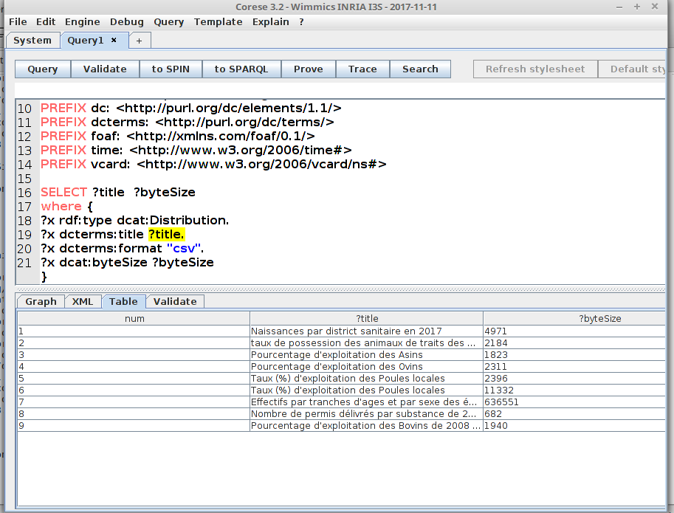

7. La liste des producteurs (publisher) depuis l’ontologies

prefix rdf: <http://www.w3.org/1999/02/22-rdf-syntax-ns#>
prefix rdfs1: <http://www.data.gov.bf/ressource/rdfs#>
prefix dct: <http://purl.org/dc/terms/>
prefix ns: <http://www.semanticweb.org/master/esi/ontologies/2021/fasopedia#>
prefix dcat: <http://www.w3.org/ns/dcat#>
PREFIX owl: <http://www.w3.org/2002/07/owl#>
PREFIX rdfs: <http://www.w3.org/2000/01/rdf-schema#>
PREFIX xsd: <http://www.w3.org/2001/XMLSchema#>
PREFIX adms: <http://www.w3.org/ns/adms#>
PREFIX dc: <http://purl.org/dc/elements/1.1/>
PREFIX dcterms: <http://purl.org/dc/terms/>
PREFIX foaf: <http://xmlns.com/foaf/0.1/>
PREFIX time: <http://www.w3.org/2006/time#>
PREFIX vcard: <http://www.w3.org/2006/vcard/ns#>

SELECT *
where {
?x rdf:type rdfs1:Publisher
}

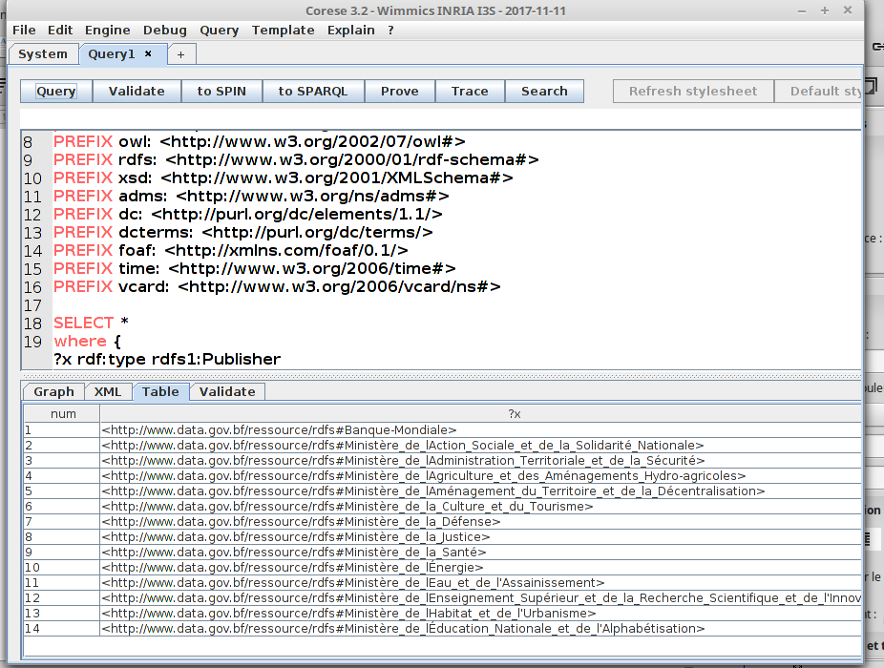

8. le nom des producteurs

prefix rdf: <http://www.w3.org/1999/02/22-rdf-syntax-ns#>
prefix rdfs1: <http://www.data.gov.bf/ressource/rdfs#>
prefix dct: <http://purl.org/dc/terms/>
prefix ns: <http://www.semanticweb.org/master/esi/ontologies/2021/fasopedia#>
prefix dcat: <http://www.w3.org/ns/dcat#>
PREFIX owl: <http://www.w3.org/2002/07/owl#>
PREFIX rdfs: <http://www.w3.org/2000/01/rdf-schema#>
PREFIX xsd: <http://www.w3.org/2001/XMLSchema#>
PREFIX adms: <http://www.w3.org/ns/adms#>
PREFIX dc: <http://purl.org/dc/elements/1.1/>
PREFIX dcterms: <http://purl.org/dc/terms/>
PREFIX foaf: <http://xmlns.com/foaf/0.1/>
PREFIX time: <http://www.w3.org/2006/time#>
PREFIX vcard: <http://www.w3.org/2006/vcard/ns#>

SELECT ?name
where {
?x rdf:type rdfs1:Publisher.
?x foaf:name ?name
}

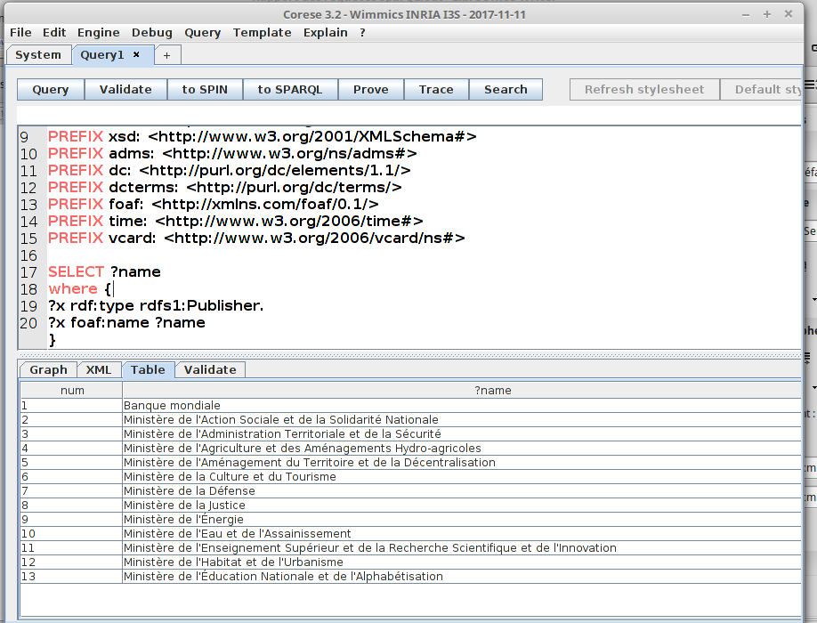

9. les producteurs publiques et privés

prefix rdf: <http://www.w3.org/1999/02/22-rdf-syntax-ns#>
prefix rdfs1: <http://www.data.gov.bf/ressource/rdfs#>
prefix dct: <http://purl.org/dc/terms/>
prefix ns: <http://www.semanticweb.org/master/esi/ontologies/2021/fasopedia#>
prefix dcat: <http://www.w3.org/ns/dcat#>
PREFIX owl: <http://www.w3.org/2002/07/owl#>
PREFIX rdfs: <http://www.w3.org/2000/01/rdf-schema#>
PREFIX xsd: <http://www.w3.org/2001/XMLSchema#>
PREFIX adms: <http://www.w3.org/ns/adms#>
PREFIX dc: <http://purl.org/dc/elements/1.1/>
PREFIX dcterms: <http://purl.org/dc/terms/>
PREFIX foaf: <http://xmlns.com/foaf/0.1/>
PREFIX time: <http://www.w3.org/2006/time#>
PREFIX vcard: <http://www.w3.org/2006/vcard/ns#>

SELECT ?name ?administration
where {
?x rdf:type rdfs1:Publisher.
?x foaf:name ?name.
OPTIONAL { ?x rdfs1:administration ?administration}
}

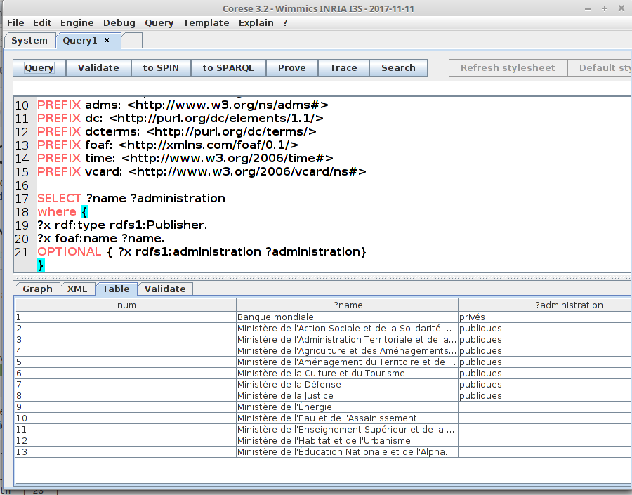

10 . Evolution du nombre de

la liste des stations pluviometriques

prefix rdf: <http://www.w3.org/1999/02/22-rdf-syntax-ns#>
prefix rdfs1: <http://www.data.gov.bf/ressource/rdfs#>
prefix dct: <http://purl.org/dc/terms/>
prefix ont: <http://www.co-ode.org/ontologies/ont.owl#>
prefix dcat: <http://www.w3.org/ns/dcat#>
PREFIX owl: <http://www.w3.org/2002/07/owl#>
PREFIX rdfs: <http://www.w3.org/2000/01/rdf-schema#>
PREFIX xsd: <http://www.w3.org/2001/XMLSchema#>
PREFIX adms: <http://www.w3.org/ns/adms#>
PREFIX dc: <http://purl.org/dc/elements/1.1/>
PREFIX dcterms: <http://purl.org/dc/terms/>
PREFIX foaf: <http://xmlns.com/foaf/0.1/>
PREFIX time: <http://www.w3.org/2006/time#>
PREFIX vcard: <http://www.w3.org/2006/vcard/ns#>

select ?name
where {
?name ?p ont:Stations
}

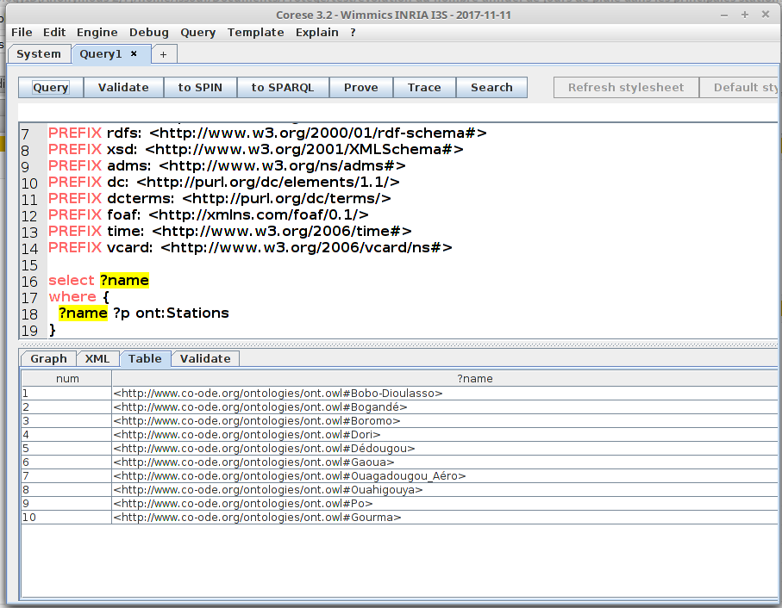

11. la quantite des pluis de boromo

prefix rdf: <http://www.w3.org/1999/02/22-rdf-syntax-ns#>
prefix rdfs1: <http://www.data.gov.bf/ressource/rdfs#>
prefix dct: <http://purl.org/dc/terms/>
prefix ont: <http://www.co-ode.org/ontologies/ont.owl#>
prefix dcat: <http://www.w3.org/ns/dcat#>
PREFIX owl: <http://www.w3.org/2002/07/owl#>
PREFIX rdfs: <http://www.w3.org/2000/01/rdf-schema#>
PREFIX xsd: <http://www.w3.org/2001/XMLSchema#>
PREFIX adms: <http://www.w3.org/ns/adms#>
PREFIX dc: <http://purl.org/dc/elements/1.1/>
PREFIX dcterms: <http://purl.org/dc/terms/>
PREFIX foaf: <http://xmlns.com/foaf/0.1/>
PREFIX time: <http://www.w3.org/2006/time#>
PREFIX vcard: <http://www.w3.org/2006/vcard/ns#>

select ?annee ?quantite
where {
ont:Boromo ?annee ?quantite
}

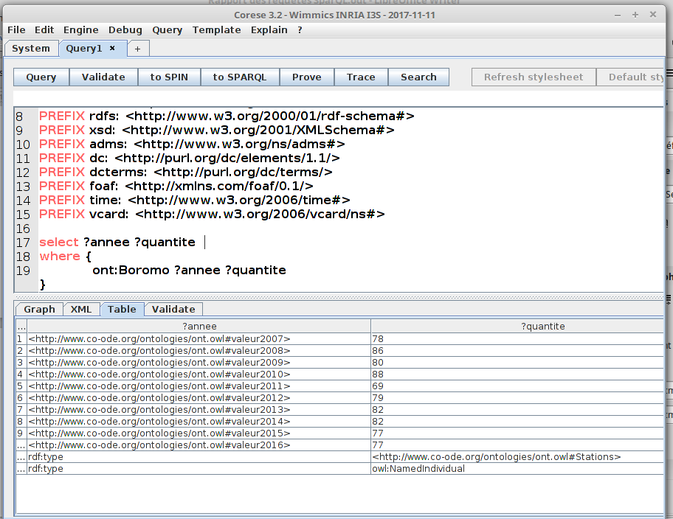

12. Quantité des pluies a Boromo en 2007

prefix rdf: <http://www.w3.org/1999/02/22-rdf-syntax-ns#>
prefix rdfs1: <http://www.data.gov.bf/ressource/rdfs#>
prefix dct: <http://purl.org/dc/terms/>
prefix ont: <http://www.co-ode.org/ontologies/ont.owl#>
prefix dcat: <http://www.w3.org/ns/dcat#>
PREFIX owl: <http://www.w3.org/2002/07/owl#>
PREFIX rdfs: <http://www.w3.org/2000/01/rdf-schema#>
PREFIX xsd: <http://www.w3.org/2001/XMLSchema#>
PREFIX adms: <http://www.w3.org/ns/adms#>
PREFIX dc: <http://purl.org/dc/elements/1.1/>
PREFIX dcterms: <http://purl.org/dc/terms/>
PREFIX foaf: <http://xmlns.com/foaf/0.1/>
PREFIX time: <http://www.w3.org/2006/time#>
PREFIX vcard: <http://www.w3.org/2006/vcard/ns#>

select ?annee ?quantite
where {
ont:Boromo ont:valeur2007 ?quantite
}

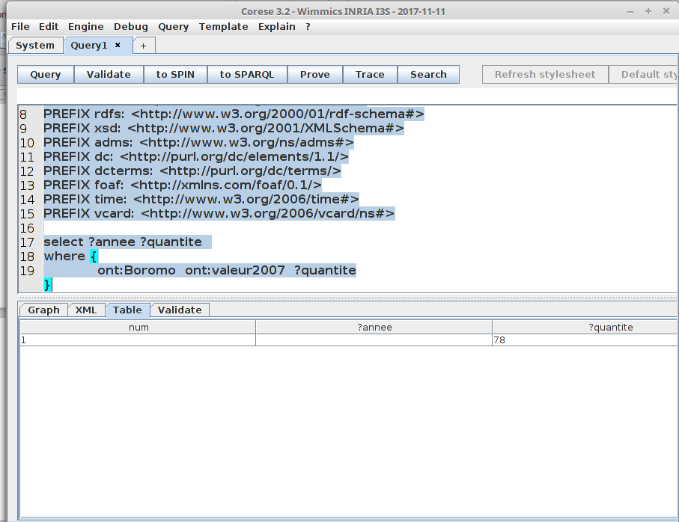

13. La listes des produits importer

prefix rdf: <http://www.w3.org/1999/02/22-rdf-syntax-ns#>
prefix rdfs1: <http://www.data.gov.bf/ressource/rdfs#>
prefix dct: <http://purl.org/dc/terms/>
prefix ont: <http://www.co-ode.org/ontologies/ont.owl#>
prefix dcat: <http://www.w3.org/ns/dcat#>
PREFIX owl: <http://www.w3.org/2002/07/owl#>
PREFIX rdfs: <http://www.w3.org/2000/01/rdf-schema#>
PREFIX xsd: <http://www.w3.org/2001/XMLSchema#>
PREFIX adms: <http://www.w3.org/ns/adms#>
PREFIX dc: <http://purl.org/dc/elements/1.1/>
PREFIX dcterms: <http://purl.org/dc/terms/>
PREFIX foaf: <http://xmlns.com/foaf/0.1/>
PREFIX time: <http://www.w3.org/2006/time#>
PREFIX vcard: <http://www.w3.org/2006/vcard/ns#>

select ?name
where {
?name ?p ont:ProduitsDimportation
}

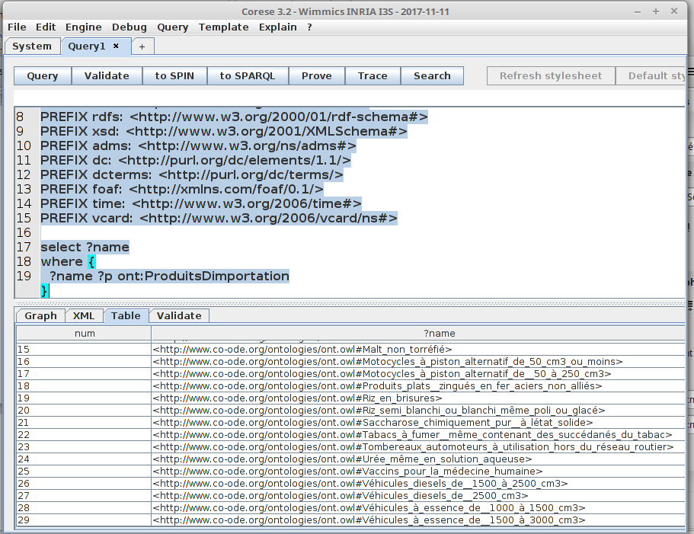

14. Ici nous allons charger les deux jeux de donneés « importation et exportation dans corese »
nous afficherons la liste des importation et des exportation .

prefix rdf: <http://www.w3.org/1999/02/22-rdf-syntax-ns#>
prefix rdfs1: <http://www.data.gov.bf/ressource/rdfs#>
prefix dct: <http://purl.org/dc/terms/>
prefix ont: <http://www.co-ode.org/ontologies/ont.owl#>
prefix dcat: <http://www.w3.org/ns/dcat#>
PREFIX owl: <http://www.w3.org/2002/07/owl#>
PREFIX rdfs: <http://www.w3.org/2000/01/rdf-schema#>
PREFIX xsd: <http://www.w3.org/2001/XMLSchema#>
PREFIX adms: <http://www.w3.org/ns/adms#>
PREFIX dc: <http://purl.org/dc/elements/1.1/>
PREFIX dcterms: <http://purl.org/dc/terms/>
PREFIX foaf: <http://xmlns.com/foaf/0.1/>
PREFIX time: <http://www.w3.org/2006/time#>
PREFIX vcard: <http://www.w3.org/2006/vcard/ns#>

select ?name
where {
?name ?p owl:NamedIndividual.
}

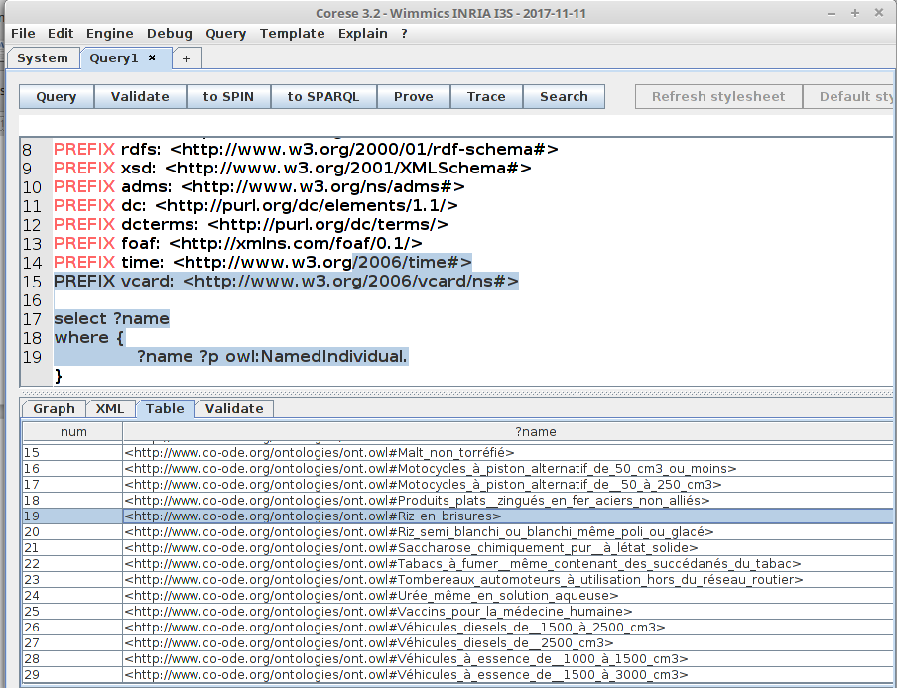

15. les importation et exportation de Autres_ciments_portlands

prefix rdf: <http://www.w3.org/1999/02/22-rdf-syntax-ns#>
prefix rdfs1: <http://www.data.gov.bf/ressource/rdfs#>
prefix dct: <http://purl.org/dc/terms/>
prefix ont: <http://www.co-ode.org/ontologies/ont.owl#>
prefix dcat: <http://www.w3.org/ns/dcat#>
PREFIX owl: <http://www.w3.org/2002/07/owl#>
PREFIX rdfs: <http://www.w3.org/2000/01/rdf-schema#>
PREFIX xsd: <http://www.w3.org/2001/XMLSchema#>
PREFIX adms: <http://www.w3.org/ns/adms#>
PREFIX dc: <http://purl.org/dc/elements/1.1/>
PREFIX dcterms: <http://purl.org/dc/terms/>
PREFIX foaf: <http://xmlns.com/foaf/0.1/>
PREFIX time: <http://www.w3.org/2006/time#>
PREFIX vcard: <http://www.w3.org/2006/vcard/ns#>

select ?quantite ?annee
where {

ont:Autres_ciments_portlands ?annee ?quantite.
}

16. les importation et exportation de autres ciment en 2000.

prefix rdf: <http://www.w3.org/1999/02/22-rdf-syntax-ns#>
prefix rdfs1: <http://www.data.gov.bf/ressource/rdfs#>
prefix dct: <http://purl.org/dc/terms/>
prefix ont: <http://www.co-ode.org/ontologies/ont.owl#>
prefix dcat: <http://www.w3.org/ns/dcat#>
PREFIX owl: <http://www.w3.org/2002/07/owl#>
PREFIX rdfs: <http://www.w3.org/2000/01/rdf-schema#>
PREFIX xsd: <http://www.w3.org/2001/XMLSchema#>
PREFIX adms: <http://www.w3.org/ns/adms#>
PREFIX dc: <http://purl.org/dc/elements/1.1/>
PREFIX dcterms: <http://purl.org/dc/terms/>
PREFIX foaf: <http://xmlns.com/foaf/0.1/>
PREFIX time: <http://www.w3.org/2006/time#>
PREFIX vcard: <http://www.w3.org/2006/vcard/ns#>

select ?quantite
where {

ont:Autres_ciments_portlands ont:valeur2000 ?quantite.
}

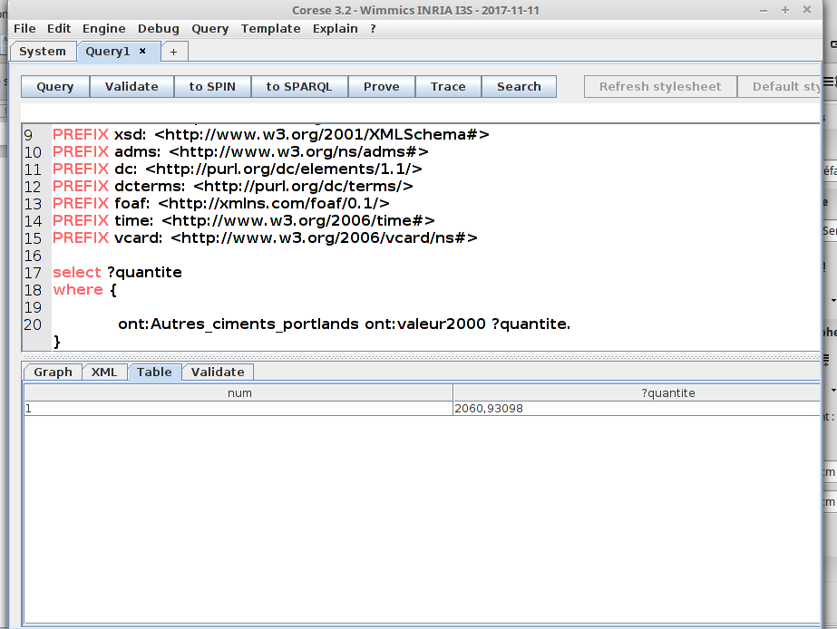
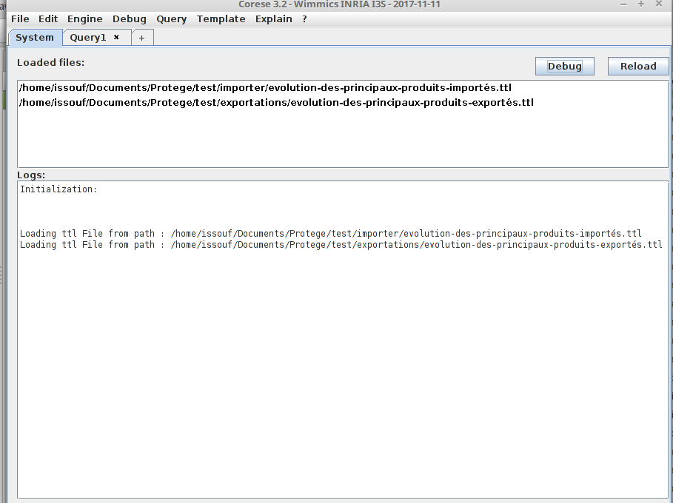

17. Classement de la plus grand quantite entre importation et exportation de produit Autres_ciments_portlands

prefix rdf: <http://www.w3.org/1999/02/22-rdf-syntax-ns#>
prefix rdfs1: <http://www.data.gov.bf/ressource/rdfs#>
prefix dct: <http://purl.org/dc/terms/>
prefix ont: <http://www.co-ode.org/ontologies/ont.owl#>
prefix dcat: <http://www.w3.org/ns/dcat#>
PREFIX owl: <http://www.w3.org/2002/07/owl#>
PREFIX rdfs: <http://www.w3.org/2000/01/rdf-schema#>
PREFIX xsd: <http://www.w3.org/2001/XMLSchema#>
PREFIX adms: <http://www.w3.org/ns/adms#>
PREFIX dc: <http://purl.org/dc/elements/1.1/>
PREFIX dcterms: <http://purl.org/dc/terms/>
PREFIX foaf: <http://xmlns.com/foaf/0.1/>
PREFIX time: <http://www.w3.org/2006/time#>
PREFIX vcard: <http://www.w3.org/2006/vcard/ns#>

select ?y (MAX (?quantite) AS ?Max_IMPORT_EXPORT)
where {
ont:Autres_ciments_portlands ?y ?quantite.
}

GROUP BY ?y

